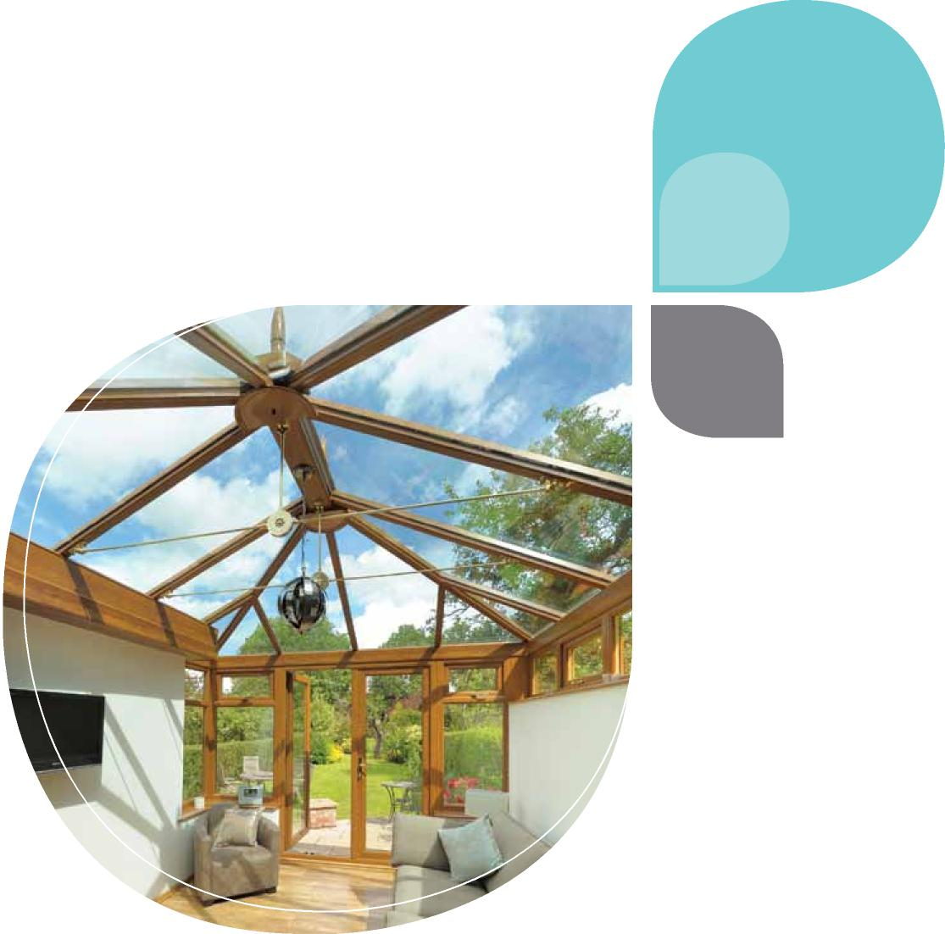
Inspiration
Design a perfect place with space and light
extend & add value

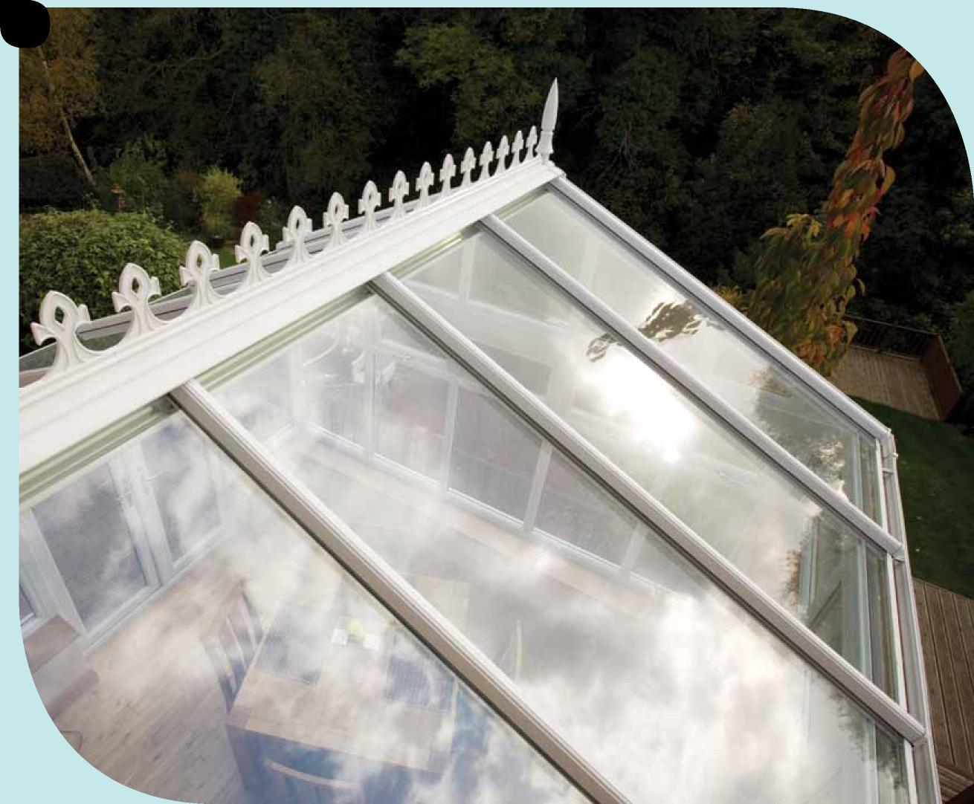
2

Inspiration | Global Conservatory Roofs
A conser_{v}atory is a c_{o}st effecti_{v}e way t_{o} increase the si_{z}e and _{v}alue of your home.
3
Beautiful PVC-U conservatories for a brighter life

We are all looking to add some extra space to our homes, maybe for a kitchen, playroom, dining room or simply a room to relax in. A conservatory creates a cost effective way to increase the value of your home and provide you with all the space and light you need for relaxing and entertaining.
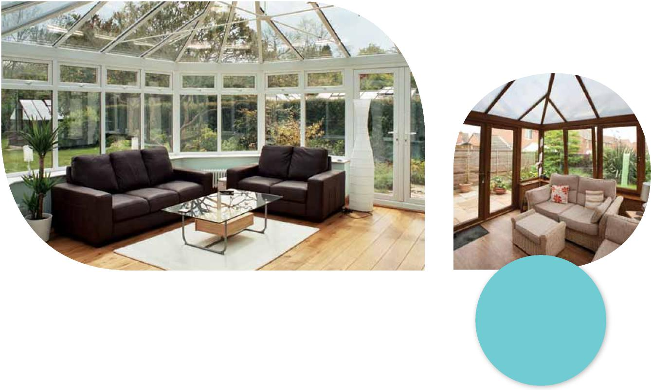
Your new conservatory will be manufactured from modern aluminium and PVC-U materials, built to last, guaranteed not to flake, rust, rot or peel, they are virtually maintenance free and require nothing more than the occasional wipe down with a damp cloth. With a variety of styles and finishes, our conservatories will complement your home perfectly and provide you with an extension that you and your family will enjoy all year round.

Design a perfect place with space and light
4
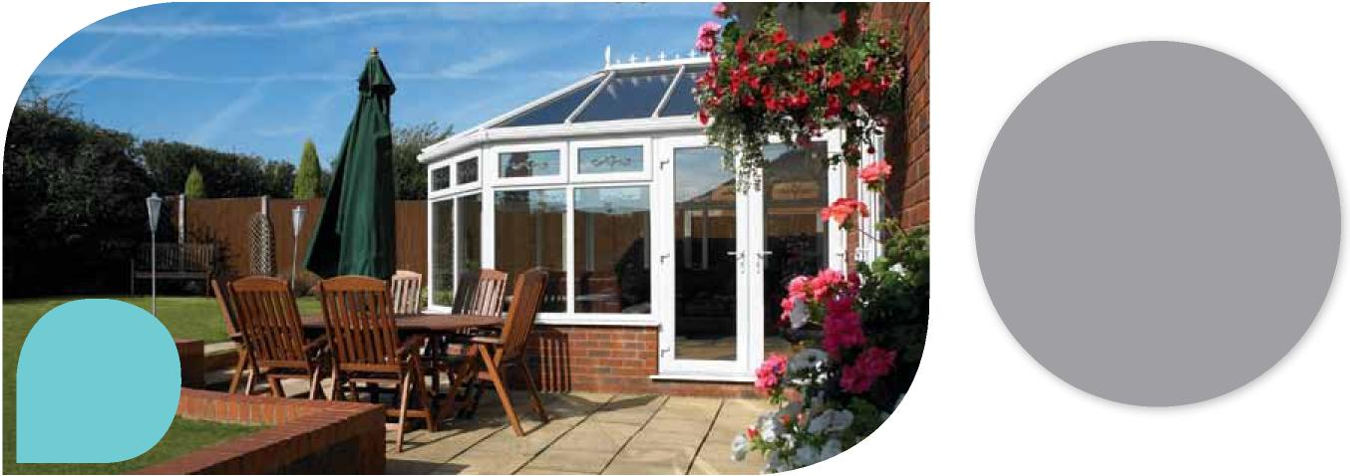
White, Victorian Detailed top openers Polycarbonate roof
There are so _{m}any
choices available fro_{m} a
c_{on}te_{m}p_{o}rary l_{oo}k t_{o} a
classic traditional style, your
conser_{v}atory can be tailored
to _{m}eet your own needs.

Are you looking for an indoor area from which to enjoy your garden, somewhere to work from home, entertain friends, somewhere to relax or just some extra space? Our conservatories are individually designed to enhance and extend your home beautifully.
Adding a conservatory to your home not only adds value to your property, but also is a relatively low cost and easy way to extend your living space. There are so many choices available from a contemporary look to a classic traditional style, your conservatory can be tailored to meet your own needs.
To help you get the most from your new conservatory we’ll give you all the guidance you require, and help you choose the ideal location that will maximise your enjoyment of your new living space.
Our conservatories are available in a wide variety of style and colour options to suit every home. With a wide range of glass styles and extras to consider, such as handles, locks, blinds and ventilation, you can rely on us to offer you advice and practical suggestions, leaving you to imagine the possibilities that a new living space can provide.

Inspiration | Global Conservatory Roofs
5

Top conservatory tips

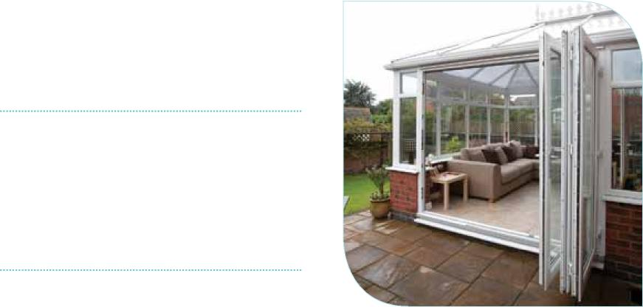
What size should it be?
What style will suit your home?
Whether your home is a period property or more contemporary, there will be a conservatory to suit every style. Try to match your conservatory seamlessly to your home in terms of brickwork, colours and style.
Do you require planning permission?
Planning permission may not be required if your conservatory meets certain criteria, e.g location, size, etc. We recommend that you check with your local planning department or conservatory installer. If you live in a listed property or a conservation area then you will certainly require the necessary approval.
What is the best position for your new conservatory to be installed?
Your installer will be able to advise you on this, consider where the sun will be in the daytime, and if you will require extra ventilation or blinds?
Try not to take up too much of your garden space. Your conservatory should be an extension of your home, but not at the expense of your lawn!
Will your conservatory be secure?
Remember to lock up - for added security ensure you lock not just your external conservatory doors but also the door linking the conservatory to your house.
Plan your conservatory carefully
Mark out where in your garden the conservatory will be. Make sure you ask your installer what the internal dimensions of the finished conservatory will be.
A dwarf brick wall or a glass wall?
Do you want your conservatory to have a low wall, or have a full height glass wall to maximise the light?
Have you considered bi-fold doors?
Bi-fold doors can open up the whole elevation of your conservatory and bring the outside in! These versatile doors can even be used from your house into your conservatory, so making use of all the space available to you.
Have you considered your neighbours?
Will your conservatory affect their enjoyment of their garden or sunlight?

Made to measure
6
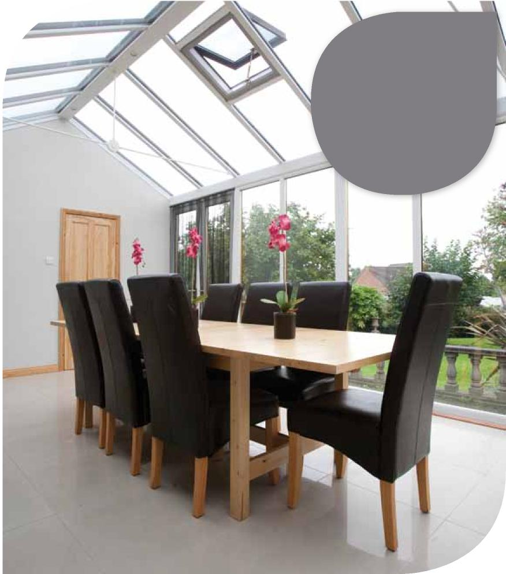
Your conser_{v}atory should
be just that - yours. There are s_{o m}a_{n}y _{o}pti_{on}s a_{v}ailable that one will be
the perfect choice for
you and your home.
The interior design of your conservatory is so important – you need to ensure your dreams and aspirations come true! Whatever style is right for you, just add the furniture, fabrics, lighting, heating and flooring to create an atmosphere to dine, work or just relax in. New designs in furniture and trends in blinds, accessories and flooring has meant that a conservatory is not just an extension, but an extra room, a room from which you can enjoy light, space and your garden.
Furniture
It is important to consider what furniture to put in your conservatory. Your new room could be the first entry into your home from the garden, which means that your furniture could potentially attract mud and grass stains, especially if you have children around! So the furniture you choose has to be up for a bit of wear and tear. Look for washable fabric cushions and removable covers, and the fabric you choose needs to be resistant to damage from sunlight. Choose solar glass to reflect the sun to help prevent fading of furniture, rugs and soft furnishings. Cane furniture is a popular choice as it is a natural material and is light enough to carry out into the garden on a lovely sunny day.

Inspiration | Global Conservatory Roofs
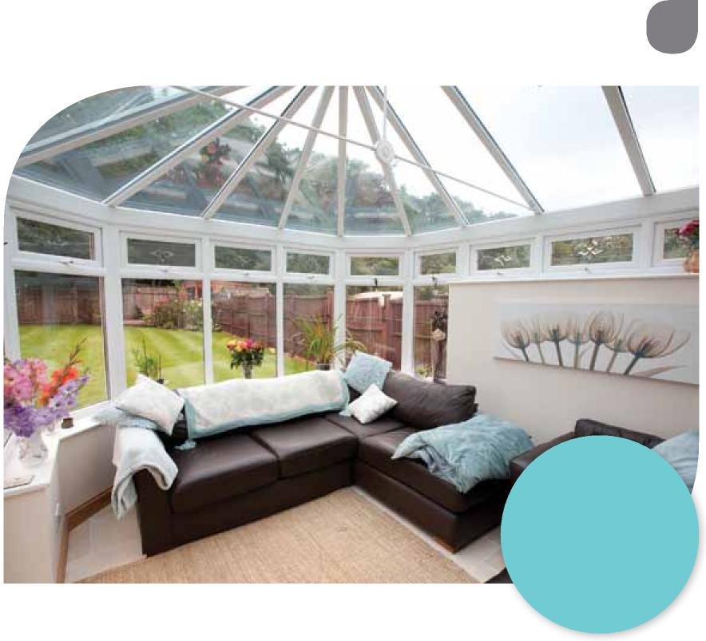
7
Flooring
Whether you choose wooden flooring or tiles, the options in terms of colour and style are endless. The floor should be easy to clean and with so many choices available you will certainly find one that suits your new room.

Blinds
A conservatory is an ideal way to bring light and space into your home, but you might need to consider some shade to control heat and glare. Blinds are an ideal solution and come in many different styles. You can choose from roller, roman, woodweave, vertical or venetian blinds. All these types of blinds are available in different patterns and colours, and can be rolled up or opened to allow the maximum amount of light to flood your room. Blinds not only look good, but also have a practical purpose.
Heating
An ideal way to heat your conservatory is with slim-line electric wall heaters - they are controllable and are small and discreet. You could even choose underfloor heating, it is an efficient way to heat your room and once installed it is invisible and you are able to design your room without having to work around radiators or wall mounted heaters.
Fans
Fans come in various sizes and can offer different speeds, forwards and backwards. Forwards to move the air around in the room and backwards to draw down the warm air which has risen and trapped in the roof, perfect for winter. Fans can be fitted with lights and can be operated with pull chains, by wall operated switches, or even by remote control.
An extra roo_{m} fro_{m} which y_{ou} ca_{n} e_{n}j_{o}y new light, space and your garden.
Glazing
You may wish to locate your conservatory near to your neighbour’s fence, or by an open road. If so, then you could choose a glazing option which will ensure that your room is kept private. Our range of solutions can offer various levels of obscuration, providing you with the privacy you require, whilst maximising the level of daylight passing through the roof.

The No. 1 best selling conservatory roof system
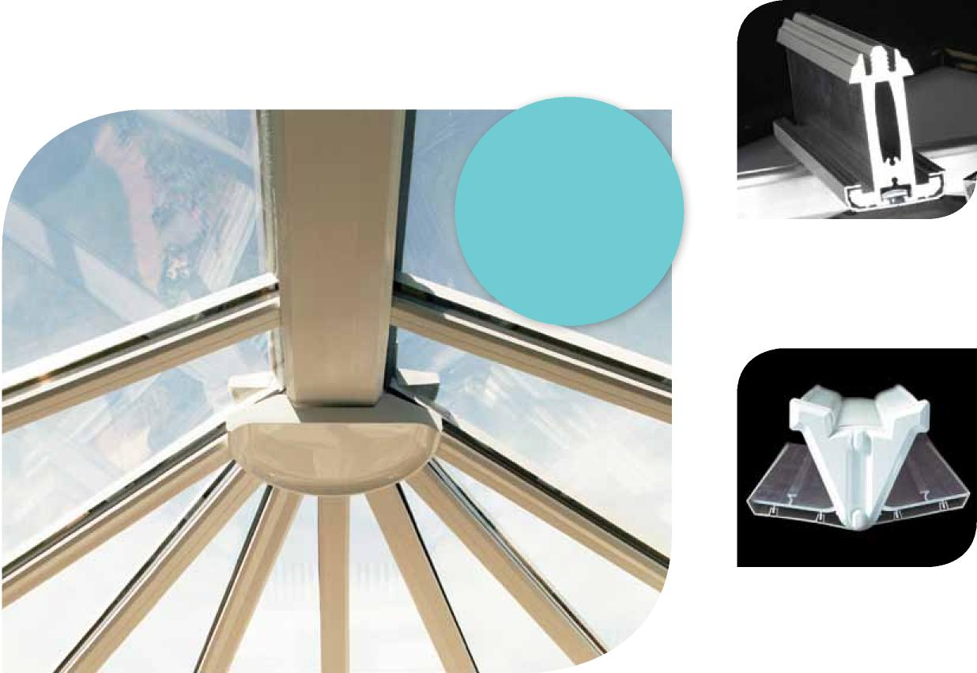
8
By choosing a Global conservatory roof you are choosing the UK’s No. 1 roof system.
It has been engineered for your peace of mind and has been exhaustively tested to ensure that it is robust, durable and long lasting. Using state-of-the-art design software, each Global roof system is designed to take conservatories to the next level and is only limited by your imagination. Our roofs have been tested and have been passed by the British Board of Agrément (BBA).

High strength rafters
E_{n}gi_{n}eered f_{o}r y_{ou}r
peace of _{m}ind and
exhausti_{v}ely tested to
ensure it’s durable, long
lasting and robust.
Designed to hold a larger roof, so you don’t have to compromise on your ideal design or weather performance.
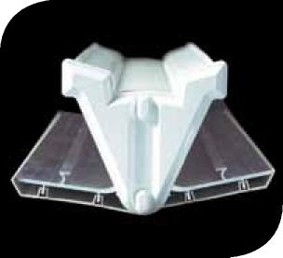
Variable valley
The valley is designed to suit varying pitches and angles and is cloaked internally and externally to give an attractive aesthetic finish.

Inspiration | Global Conservatory Roofs
9

Tie bolt
Our precision engineered security locking bolt eradicates movement between the bolt and rafter, to give a strong and rigid anti-slip joint connection.
Perfect lead flashing
The starter bar is designed to leave a perfect lead flashing line seamlessly connecting the house and conservatory. The lead dresses into a built-in soaker forming a watertight seal and no lead needs to be dressed over the top cap, therefore preventing unsightly staining.
Low level gasket system
No one wants to look at their conservatory roof and see thick black gaskets around every glazing bar. That’s why we have designed our roof with concealed gaskets.

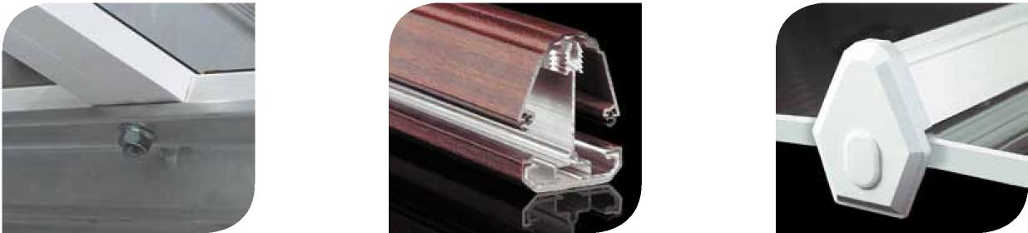

Single fixing bolt
We don’t think it’s a good idea to drill holes in something that should be fully watertight, that’s why our single bolt fixing sits within its own purposely designed channel, which is then concealed from view by decorative internal trims.
Aluminium woodgrain and painted top caps Our woodgrain and painted external top cappings are made from aluminium, so they will not warp or distort under extreme heat or split under extreme cold.
End caps
All external rafter end caps have a shoulder around the visible face for a more substantial and decorative appearance.

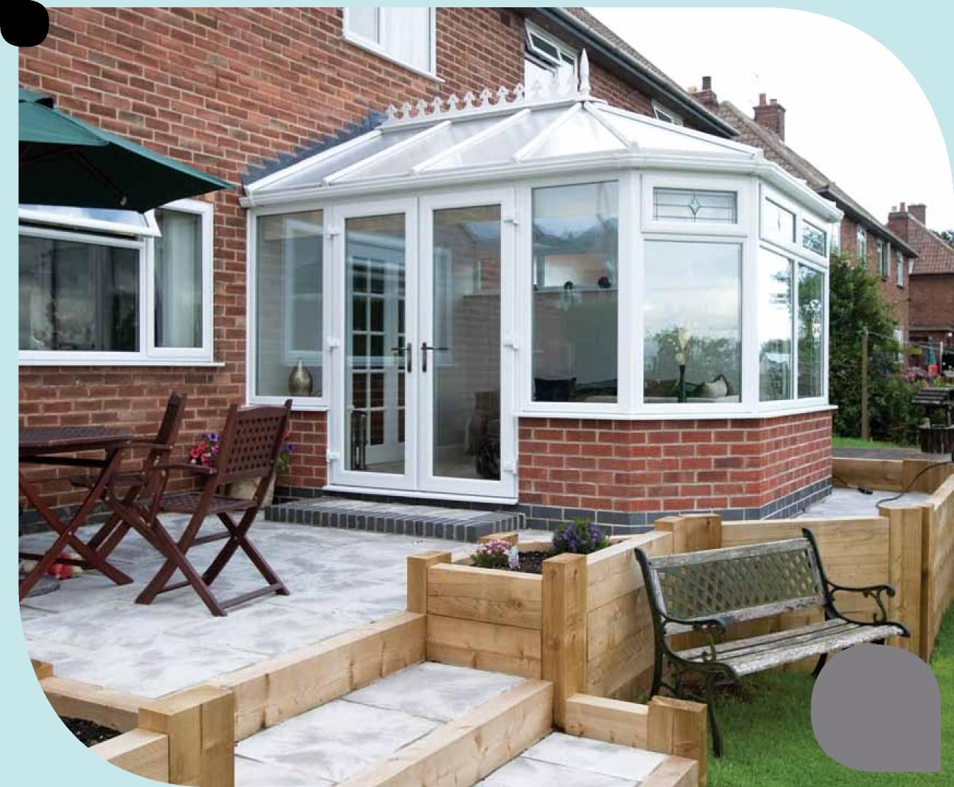
10
White Victorian
Polycarbonate roof

Inspiration | Global Conservatory Roofs
11

A style for every customers’ home
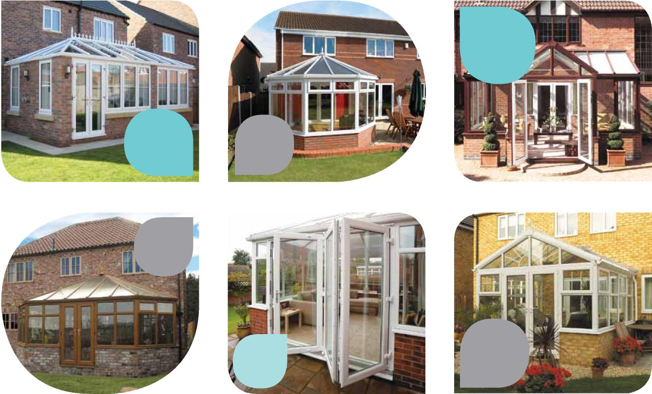
White woodgrain Double hipped Silver hardware Glass roof
Rustic Cherry Victorian Gold hardware
White Victorian Detailed top openers
White Edwardian Bi-fold doors
Mahogany outside White inside T-shaped
White Gable Glass roof White handles
Whatever your house style we can design you a conservatory which will suit your home perfectly. To follow are some examples you could choose from.

12
Georgian & Edwardian
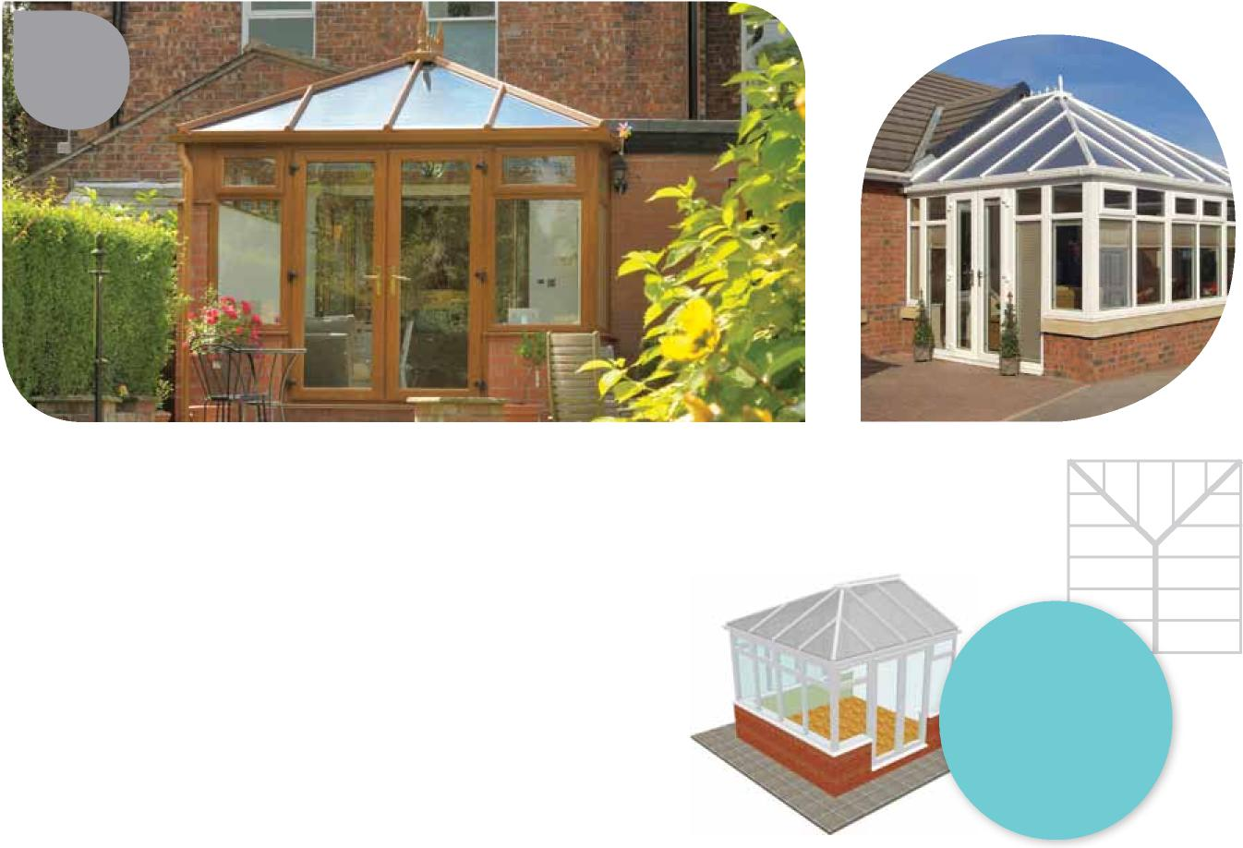
This style of conservatory can be installed onto any property, but the styling is best showcased on properties with existing Georgian or Edwardian architecture or features.
The Georgian and Edwardian conservatory will allow your new extension to flood with light due to its high roof style which gives the room a bright and airy feel.
With its flat front and rectangular/square shape, the conservatory ensures no wasted space, so plenty of room for your furniture, plants or new kitchen.
Rustic Cherry Gold hardware Glass roof
The straight sides of the conservatory
also make it an ideal choice for combining with a bi-fold door, creating a stunning and versatile addition to your home.
Referred to as either a Georgian or Edwardian style, this is a classic conservatory type that combines practicality with style.
A square fronted
duo-pitch roof
with a central ridge,
providing a flat fronted
design that optimises
floor space.

Inspiration | Global Conservatory Roofs
13

Victorian
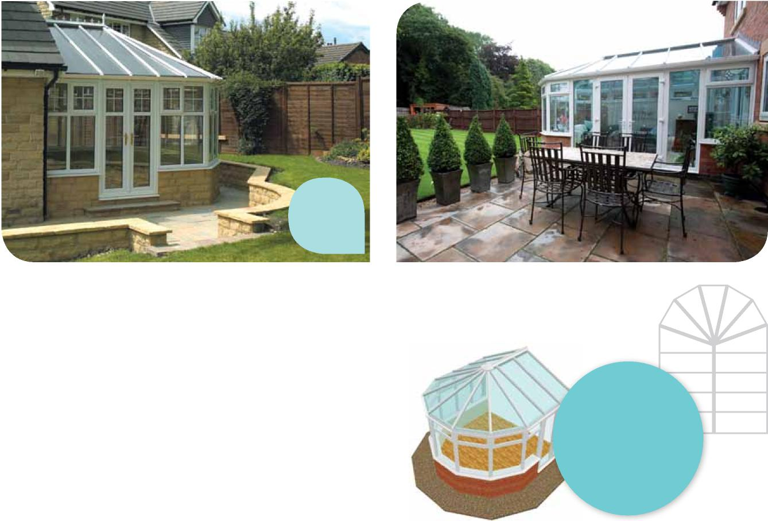
The Victorian conservatory also provides an elegant way to soften the transition between your house and garden.
The Victorian conservatory is a timeless design that adds a touch of elegance to your home.
Victorian conservatories typically have a 3 or 5 panel faceted end which gives them their unique look and charm. This multi-faceted bay gives excellent all-round views and can help extend your enjoyment of your garden, as you watch the changing seasons from the comfort of your new conservatory.
White Gold handles Georgian bar detail
A bay fronted
duo-pitched roof with
a central ridge, normally
with three or occasionally
five segments at
the front.

Gable
14
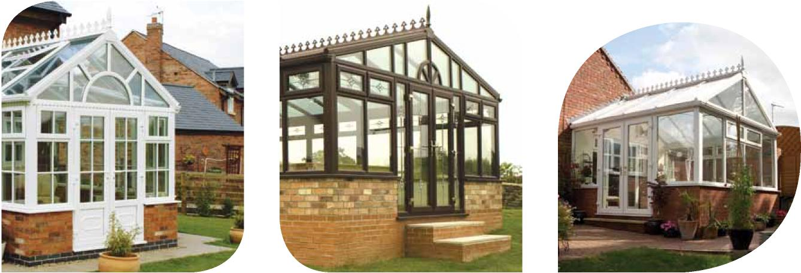

Gable style conservatories have two sloped roof sections ending in a vertical gable end, like many house designs. The Gable style of conservatory works extremely well with older properties, and can help to echo the style of the main building.
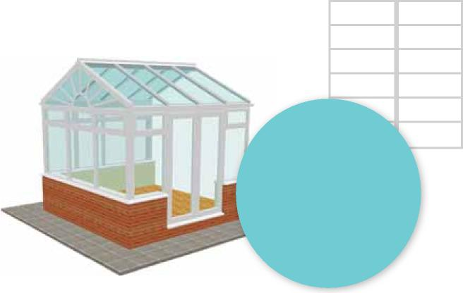
Gable ended roofs are a variant of the Edwardian style roof and consist of duo-pitched sides with
a flat faced frontage.
With a sense of architectural grandeur, the Gable end conservatory offers a light and airy design, additional headroom and excellent use of the available internal floor space.

Inspiration | Global Conservatory Roofs

Lean-to
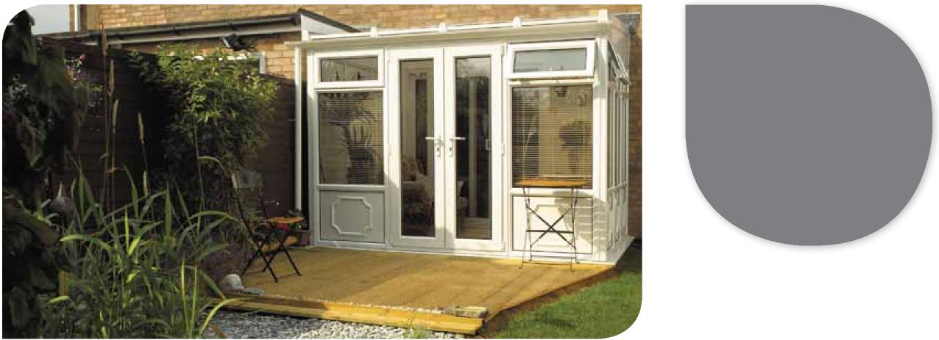
An ideal solution
t_{o} exte_{n}d y_{ou}r li_{v}i_{n}g
space with a sun roo_{m}
or garden roo_{m}.
Choose a two walled
option to gi_{v}e a _{m}ore
s_{u}bsta_{n}tial desig_{n}.

The Lean-to style of conservatory is

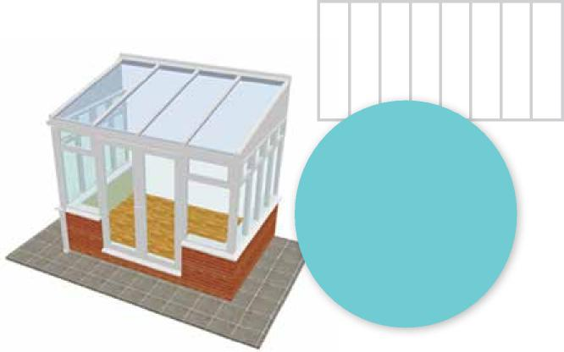
15
A conservatory with
a mono pitched roof.
The pitch of the roof
can be varied making it
a versatile option.
usually rectangular with a roof that slopes away from the property. The effect is modern, uncomplicated, with clean and simple lines, making them suitable for all house designs.
A Lean-to is often referred to as a sun room or garden room, and is an ideal style for properties with a limited amount of space. The pitch of the roof is variable so it is able to fit under low roofs, such as commonly found on bungalows, or with a steeper pitch for a detached house.

16
P-shaped | Lantern | Custom
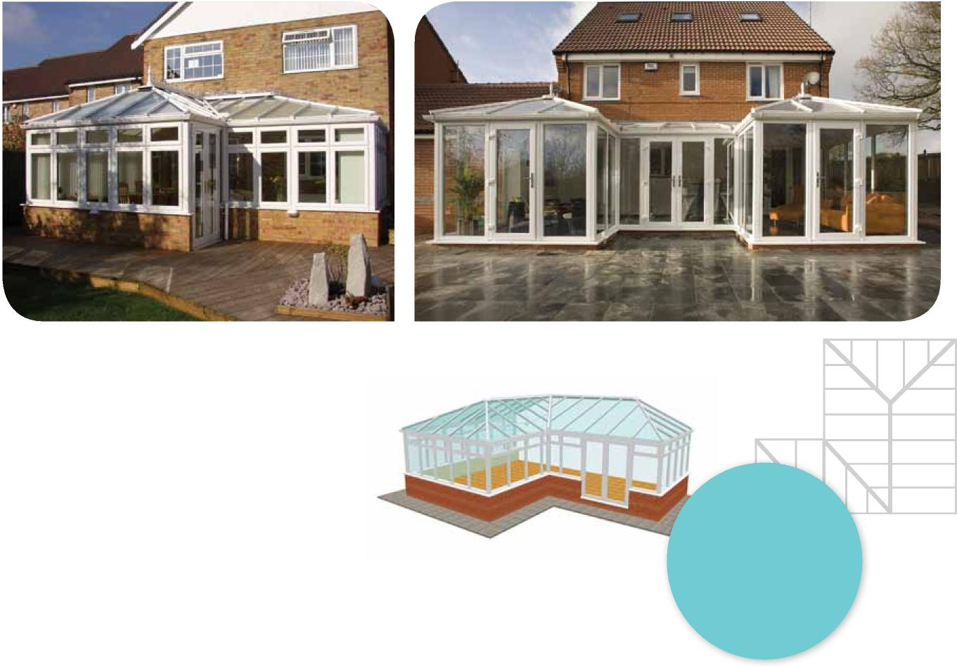
By combining a mix of conservatory shapes you will be able to achieve more space and greater levels of flexibility – why not add a Lean-to to a Georgian, or a Lean-to and a Victorian, with a 3 or 5 faceted front?
Whether you are wanting to create a P or T-shaped conservatory or something more unusual, such as a raised lantern roof design, we will handle the whole project for you - from design through to project management and build. Leaving you with a custom-made conservatory perfectly suited to your individual requirements.
The P-shaped can combine a Lean-to
section at the side of a Victorian/Edwardian shaped roof to create a versatile open space.

Inspiration | Global Conservatory Roofs
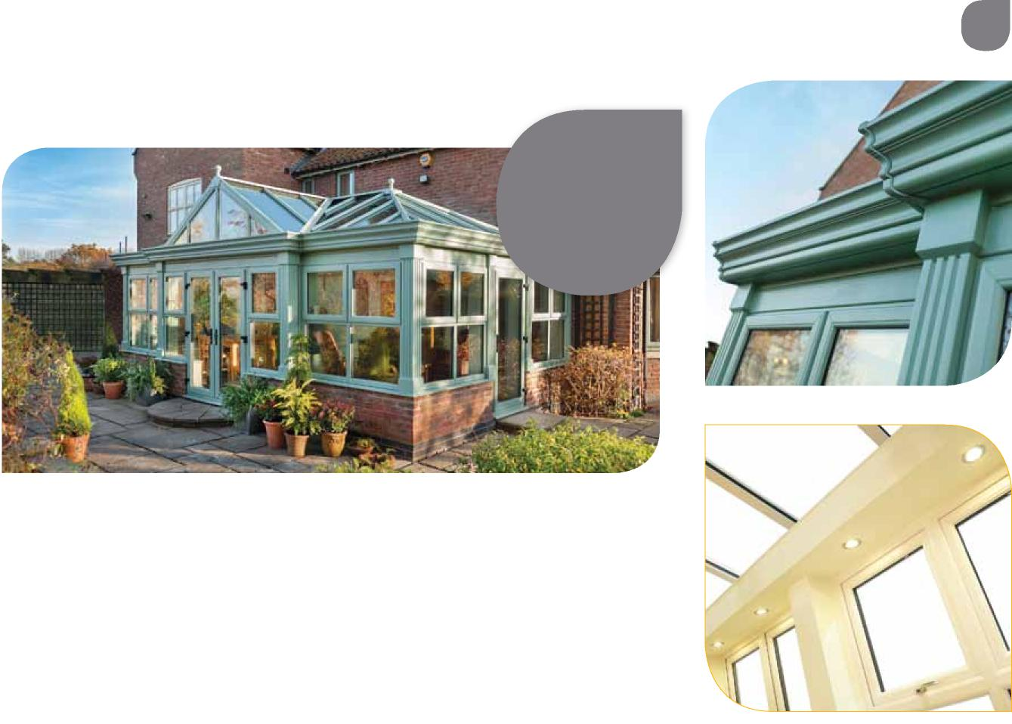
17
Orangery

An elegant and
stylish way t_{o} enjoy war_{m} and bright space all
year round.

Imagine an elegant and comfortable room, which delivers a warm and bright space that is the envy of all. This is what an orangery will bring to your home. Relax on warm summer evenings and yet enjoy a feeling of comfort and warmth during winter months.
Enhancing the Global range of proven conservatory designs and manufactured from the state of the art modern materials, the scope is endless. Orangeries can provide a unique multi-purpose living space for every home, from kitchen extension, living room, dining room or playroom. Our orangery uses the market leading Global roof with a well engineered internal framework, which is then
plastered, which gives the roof a perimeter ceiling all the way round. Within this perimeter ceiling you can choose to add downlighters or speakers giving you the opportunity to personalise your new room.
Viewed from outside, the roof of the
orangery is partially hidden by a decorative fascia and this shapely cornice conceals the orangery gutter for a more attractive external appearance. A conventional fully glazed conservatory might not be for everyone’s taste, therefore the added style and decorative elegance of an orangery creates a more substantial and interesting effect.

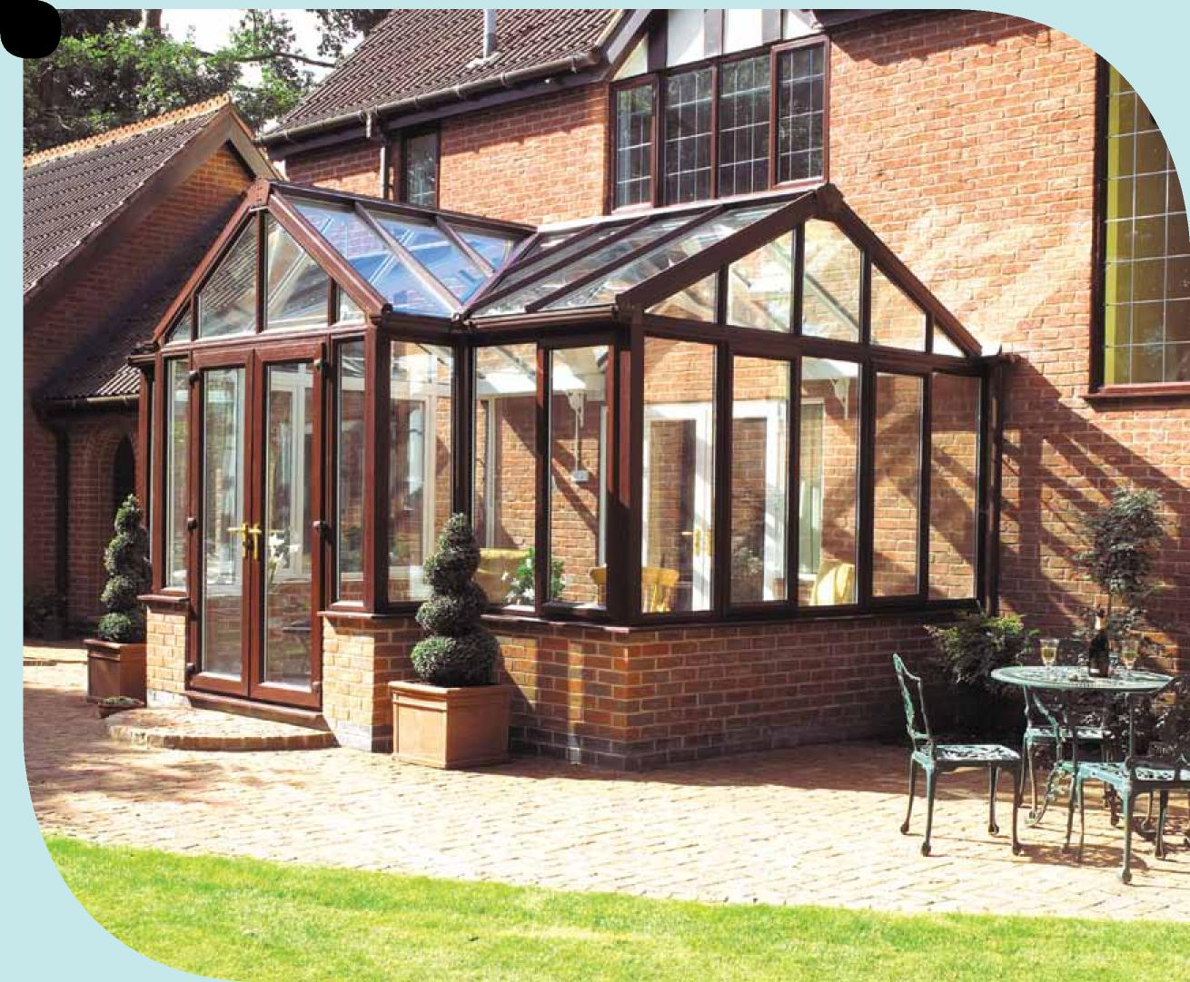
18

Inspiration | Global Conservatory Roofs
19

Live life in fabulous colour

Get out of neutral! Add warmth and style to your home with a range of coloured conservatories. Coloured frames offer an authentic alternative to timber-built ones, but without the associated problems of high maintenance and of course cost.
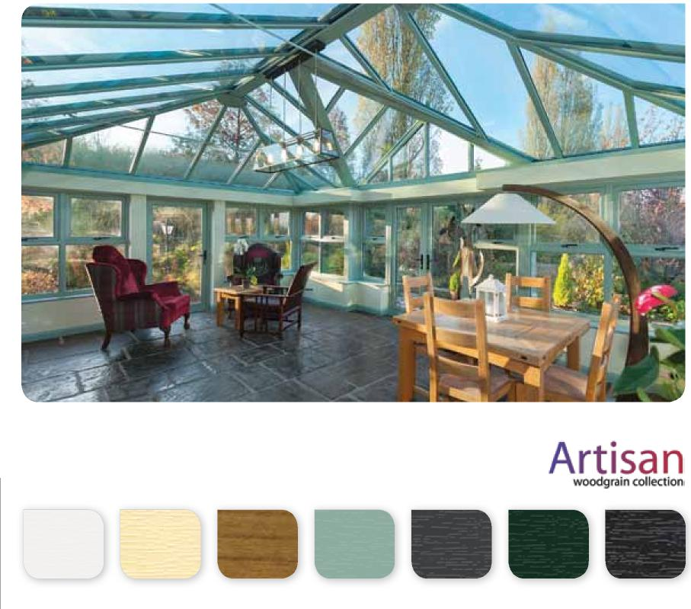
Black/Brown
Woodgrain White
Cream Rustic Cherry Chartwell Green Grey Green
Artisan woodgrain collection
The colours shown are designed as a guide to the Woodgrain and Artisan Woodgrain Collection. Before making your final decision, please ensure you have seen a colour swatch.
The colour revolution has taken over Europe over the last 20 years, with 40% of European homes choosing a coloured product... and the UK is catching on fast. White is still the most popular exterior and interior colour on the windows of Britain’s homes, but more and more people are personalising their homes to suit their style.
Why not have a woodgrain finish on the exterior and maintain White on the interior? Bring your home to life with colour and style. For a more creative look, choose a coloured finish from our Artisan range.
Woodgrain collection
Golden Oak Cherrywood Mahogany

Glazing options
20
A re_{v}olutionary
coating can be applied
t_{o ou}r glass a_{n}d
therefore lasts the
lifeti_{m}e of the glass.
Your choice of conservatory roof is extremely important. With a choice of glass or polycarbonate you’ll be able to find an option that suits you perfectly.

Glass
Our range of Low E, low maintenance and solar control glasses are the perfect choice for customers looking for the ultimate in glass solutions. A glass roof dramatically improves the views from within your new conservatory, allows for more natural sunlight and instantly gives your new conservatory that all important wow factor.
Low E glass
Low E glass has a microscopic metal coating which reflects the heat back into the room. Double glazed units which incorporate this glass offer up to 33% better insulation than conventional insulating glass units, therefore keeping your home warmer and reducing your heating bills.
Low maintenance glass
A revolutionary coating can be applied to glass as part of the manufacturing process, which means that it is fused to the surface of the glass and therefore lasts the lifetime of the pane. The coating uses the rain and natural light from the sun to efficiently combat the dirt and grime that accumulates on the outside of the window. By reducing the need for manual cleaning it provides the ideal solution for keeping those dangerous or hard to reach areas clean, leaving you more time to relax and enjoy your conservatory.
Normal glass Low maintenance glass
How does it work? There are two processes. Firstly, the special coating harnesses the natural daylight which triggers the breakdown of the dirt and grime on the outside of the glass and secondly, when the rainwater hits the glass, rather than forming droplets, it flattens and spreads out across the surface of the glass helping to wash away the dirt and grime. This sheeting effect also minimises spots and streaks by helping the glass to dry more quickly and evenly.
- A permanent coating that lasts the lifetime of the window
- Perfect for areas that are hard to clean
- Glass stays cleaner for longer
- Less dirt and grime adheres to the window, so any cleaning is quick and easy
- Reduced window cleaning bills
- Less frequent use of cleaning materials, so kinder on the environment
- Available in a range of tint colours.

Inspiration | Global Conservatory Roofs Solar control glass

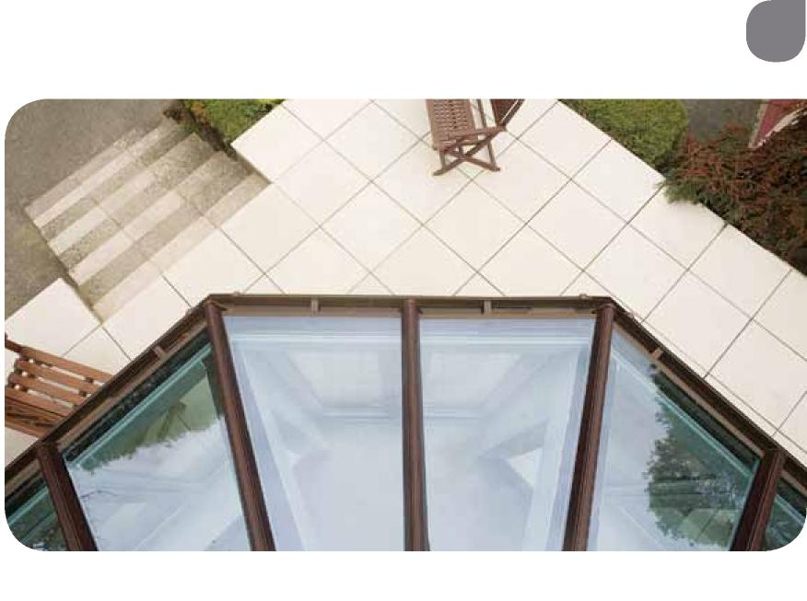
21
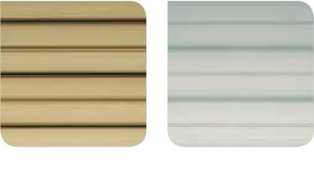
Bronze
Silver Opal
Solar control glass can be used on our conservatory roofs to help prevent the build-up of heat during the hot summer months. The coating on the glass helps reflect the heat from the sun back to the outside of the conservatory giving you a more comfortable and usable living space. The glass is available in a range of tints which allows the glass to absorb more heat, whilst the coating reflects the heat back to the outside.
- Tinted to absorb the heat
- Coated to reflect the heat back to the outside
- Tint and coating together absorbs and reflects heat for maximum comfort
- Eliminates the need for expensive window dressing
- Reduced fading of carpets and furniture.

Aqua Bronze
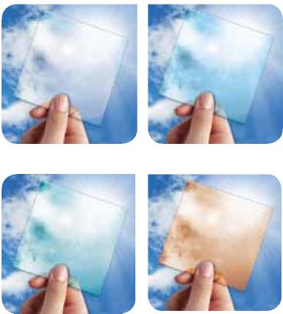
Clear glass
Blue
Polycarbonate
Polycarbonate is a light-weight insulating glazing material manufactured from damage resistant material, which provides resistance against the effects of UV weathering.
- High natural light transmission
- Range of clear and tinted options
- Excellent structural durability
- Thermally insulating options
- Damage and impact resistant
- Weatherable and UV resistant.
Clear Opal

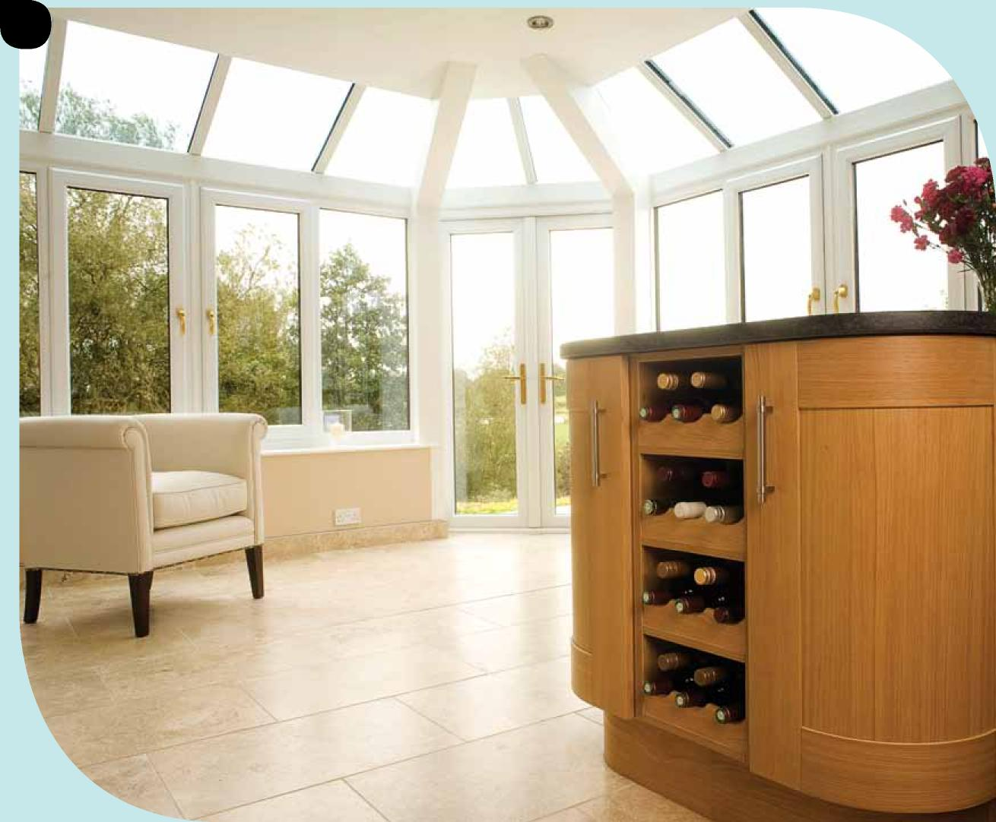
22

Inspiration | Global Conservatory Roofs
If you would like to k_{n}ow how we ca_{n} stylishly exte_{n}d your ho_{m}e, the_{n} call us today!
23
Take the next step

We aim to make it easy. That’s why your next step is simple, just pick up the phone or send us an email to register your interest and request a free quotation. We’ll then arrange to survey your home and provide a quotation, free of charge.
From the initial design consultation, through the various stages of production and installation, we employ professional and fully trained staff to coordinate your conservatory build.
A conservatory is a cost effective way to increase the si_{z}e and _{v}al_{u}e _{o}f y_{ou}r home.

Inspiration
extend & add value
Order ref: ZMG/Brochure 126NOV12/v3 GLOBAL

